Applied Research Project Proposal

A Decision-Oriented Conversational Shopping Assistant with Preference Elicitation and Explainable Recommendations

1. Introduction
Online shopping platforms have significantly reduced information search costs, yet purchasing decisions remain cognitively demanding for users. Most e-commerce systems assume that users can clearly articulate their preferences through keywords and filters. In practice, however, users often begin with vague, incomplete, or evolving needs, such as balancing price, delivery speed, usability, and long-term value.
Conversational AI tools have recently been introduced into shopping experiences to address this challenge. While these tools allow natural language input, they often fail to support structured decision-making. Outputs are frequently low in informational density, lack continuity across interactions, and provide limited transparency into why certain products are recommended.
This project addresses the gap between information retrieval and decision support in online shopping. The proposed system is a conversational shopping assistant designed not merely to retrieve products, but to help users reason through decisions. By integrating interactive preference elicitation, decision modeling, recommendation ranking, and explainable trade-offs into a unified workflow, the system aims to reduce cognitive load and increase decision confidence.

2. Related Work
This project relates to research in e-commerce recommender systems, conversational agents for shopping, and AI-assisted decision support. However, existing solutions exhibit structural limitations in preference handling, information presentation, and explainability.

Search-Oriented E-Commerce Platforms
Platforms such as Google Shopping and Amazon primarily rely on keyword search and filters. These systems assume users know exactly what they want and can iteratively refine queries. However, when users introduce new constraints (e.g., “modern style” after specifying color), earlier preferences are often overwritten rather than preserved. Users must mentally manage trade-offs across interactions, increasing cognitive burden.

Conversational Shopping Assistants
Chat-based systems such as ChatGPT-based shopping suggestions and Amazon Rufus allow natural language input but typically present limited product sets with minimal attributes (often only image and price). Critical decision factors such as delivery time, promotions, and availability are frequently missing. Moreover, users are often required to navigate multiple steps to reach actionable product pages, introducing unnecessary friction. Continuous preference refinement across turns is also weak or inconsistent.

AI-Powered Answer Engines
Tools like Perplexity excel at generating explanatory text but separate conversational reasoning from shopping workflows. Users must switch between chat interfaces and shopping pages, losing conversational context and structured constraints.

Recommender Systems
Traditional recommender systems focus on predicting user behavior or preferences using historical data and machine learning models. While effective at ranking items, they often operate as opaque black boxes and optimize engagement rather than decision clarity. This project overlaps with recommender systems but reframes the task as decision support, prioritizing transparency and user understanding over prediction accuracy.

3. Research Objectives
The primary objective of this project is to design and evaluate a decision-oriented conversational shopping assistant that supports users throughout the entire decision-making process, rather than focusing solely on product retrieval or recommendation accuracy.
Specifically, this project aims to achieve the following objectives, each corresponding to a key component of the proposed decision-support system:

Objective 1: Interactive Preference Elicitation
Design an interactive conversational mechanism that transforms users’ vague and unstructured needs into structured decision-relevant inputs.
This objective focuses on enabling users to clarify constraints, priorities, and usage contexts through natural language interaction, without requiring explicit feature weighting or technical specification.

Objective 2: Multi-Criteria Decision Modeling
Model shopping decisions as multi-criteria decision problems, explicitly representing decision variables, constraints, priorities, and trade-offs.
This objective emphasizes structuring the decision logic independently of specific recommendation algorithms, ensuring transparency and controllability in how alternatives are evaluated.

Objective 3: Constraint-Aware Recommendation Generation
Develop a recommendation framework that ranks feasible alternatives based on structured preferences and decision logic, rather than implicit click prediction or engagement metrics.
This objective investigates how rule-based, scoring-based, or hybrid approaches can be used to surface suitable options within a constrained decision space.

Objective 4: Explainable Recommendation and Interaction
Provide explainable recommendations that clearly communicate why products are suggested, which criteria they satisfy, and what trade-offs are involved.
This objective aims to support user trust and decision confidence by making the system’s reasoning process transparent and interpretable.

Objective 5: Post-Purchase Lifecycle Decision Support
Demonstrate how decision support can be extended beyond the point of purchase by integrating products into post-purchase usage scenarios.
This objective explores how continued interaction—such as support for daily routines, planning, or content usage—can reinforce decision satisfaction and validate the original decision rationale over time.

Objective 6: End-to-End Decision Workflow Demonstration
Demonstrate the proposed system as an end-to-end decision-support workflow through a realistic, scenario-based interactive demo.
This objective serves to validate the feasibility and coherence of the integrated system design, illustrating how preference elicitation, decision modeling, recommendation, explainability, and lifecycle support operate together in practice.

4. System Overview and Conceptual Framework
The proposed system is designed as a decision-oriented conversational shopping assistant that supports users across the entire purchasing lifecycle. Rather than centering on a single recommendation algorithm, the system adopts a multi-layered decision support architecture that reflects how users actually reason, compare, and evaluate options in real-world shopping scenarios.
The system consists of five interconnected logical layers, each addressing a distinct aspect of the decision-making process.

Layer 1: Preference Elicitation
Users rarely begin shopping with fully specified requirements. Instead, they express vague, contextual, and evolving needs, such as convenience, lifestyle fit, or perceived value.
The first layer focuses on interactive preference elicitation, where the system engages users through natural language conversation to gradually transform ambiguous needs into structured decision inputs. Rather than asking users to assign explicit feature weights, the system guides users to clarify constraints, priorities, and usage contexts through targeted follow-up questions.
For example, a high-level request such as “I want something convenient for cooking” may be incrementally translated into concrete attributes such as budget limits, screen size preferences, delivery urgency, and household usage patterns. This layer emphasizes decision framing and human-centered interaction, rather than algorithmic inference.

Layer 2: Decision Modeling
Once preferences are elicited, they are formalized within a decision modeling layer. Here, shopping is represented as a multi-criteria decision problem, consisting of decision variables, constraints, and trade-offs.
This layer defines what constitutes a feasible and desirable option by explicitly modeling factors such as price thresholds, feature requirements, and contextual priorities. Importantly, this step is independent of any specific recommendation algorithm; it establishes the logical structure of the decision itself.
By externalizing decision logic, the system shifts from implicit ranking to explicit reasoning, enabling more transparent and controllable decision outcomes.

Layer 3: Recommendation Algorithm
The recommendation algorithm operates within the constraints defined by the decision model. Rather than predicting what a user is most likely to click, the algorithm’s role is to rank feasible alternatives based on structured preferences and decision criteria.
This layer may employ rule-based ranking, weighted scoring, or hybrid approaches, depending on data availability and complexity. However, the algorithm is intentionally constrained and interpretable. Its purpose is not to replace user judgment, but to efficiently surface candidate options that best satisfy the modeled decision framework.

Layer 4: Explainability and Interaction
To support user trust and confidence, the system includes an explainability and interaction layer that translates decision logic into human-understandable explanations.
Instead of presenting opaque rankings, the system communicates why certain products are recommended, which criteria they satisfy, and what trade-offs are involved. This layer enables users to quickly assess alignment with their priorities and adjust preferences if needed, reinforcing an iterative and collaborative decision-making process.
Explainability here functions not only as transparency, but as an active decision aid.

Layer 5: Post-Purchase Lifecycle Support
Unlike conventional shopping assistants that terminate interaction at the point of purchase, the proposed system extends decision support into the post-purchase phase.
This lifecycle-oriented layer demonstrates how purchased products integrate into daily routines, such as meal planning, family scheduling, entertainment, or wellness management. These post-purchase interactions are designed to reinforce the original decision rationale, helping users experience the long-term value and trade-offs they accepted during the purchase.
By supporting users beyond the transaction itself, the system strengthens decision satisfaction, reduces post-purchase regret, and positions the assistant as a long-term decision partner rather than a one-time recommendation tool.

Summary
Together, these five layers form a unified decision-support workflow that spans preference discovery, decision structuring, recommendation, explanation, and lifecycle reinforcement. This architecture differentiates the proposed system from traditional recommender systems and shopping assistants by prioritizing decision quality, transparency, and sustained user value over short-term engagement metrics.

5. Data (Data sources, features, characteristics, limitations)
This project will construct a small but structured product database to support a scenario-based shopping assistant demo. The initial scope will focus on one visually distinctive product category (e.g., smart displays) to keep the dataset manageable while still supporting meaningful trade-off decisions.
Data Sources
- Publicly available product information from major e-commerce platforms and brand sites (e.g., product title, key specs, list price, promotion badge, availability, delivery estimate when available).
- Review-related signals (e.g., rating, review count, summary highlights) if accessible from public sources or curated samples.
- A manually curated “ground truth” attribute table for a subset of products (used to validate completeness and support explainability).
Data Storage and Structure
- A relational database will be created to store product and seller-level information, enabling filtering, comparison views, and traceable recommendation logic.
- Suggested tables:
  - Products (product_id, name, brand, category, price, image_url, product_url, etc.)
  - Product_Specs (product_id, spec_name, spec_value)
  - Offers (product_id, seller/platform, promotion_flag, delivery_time_estimate, availability_status)
  - Reviews_Signals (product_id, rating_avg, review_count, extracted_highlights if available)
  - User_Preferences (session_id, constraints, priorities, feature interests)
Key Features (Decision-Relevant Attributes)
- Core: price, screen size, voice control, use-case tags (recipe display / entertainment / family hub), product availability
- Decision frictions: delivery time estimate, promotion status, platform/seller, one-click link to product page
- Optional trust signals: rating, review count, short evidence snippets or summarized review themes
Limitations
- The dataset will not be exhaustive; it will prioritize “decision-critical” attributes over full catalog coverage.
- Delivery time and promotion information may be inconsistent across sources; some values may be approximated or standardized for the demo.
- Review evidence may be limited by accessibility; the proposal will clearly distinguish verified fields vs. curated/demo fields.

6. Proposed Methods (Algorithms and unique approach)
This project is not only a recommender system; it proposes a decision-oriented, end-to-end workflow that integrates five logical layers into one unified experience. The goal is to support how users decide, not merely to retrieve products.

Layer 1: Preference Elicitation (conversation → structured inputs)
- Use an interactive question flow to transform vague needs into structured preference signals:
  - Constraints (budget, delivery deadline, size limits)
  - Priorities (e.g., cooking support vs. entertainment vs. family scheduling)
  - Trade-off tolerance (e.g., “willing to pay more for a larger screen”)
- Output: a structured preference profile (rules + weights + must-haves).

Layer 2: Decision Modeling (multi-criteria decision framework)
- Formulate the choice as a multi-criteria decision problem:
  - Hard constraints: budget ceiling, minimum screen size, delivery window, availability
  - Soft preferences: feature importance weights, usage context weights
- Candidate modeling approaches:
  - Weighted scoring model (interpretable baseline)
  - Simple MCDA methods (e.g., weighted sum, rank-based scoring)
  - Rule-based constraint satisfaction + scoring hybrid (recommended for transparency)

Layer 3: Recommendation / Ranking (feasible set → ranked list)
- Generate a feasible set of products from the database using constraints.
- Rank feasible alternatives using the decision model:
  - Baseline: transparent scoring + tie-break rules
  - Optional extension: hybrid ranking (rules + lightweight ML if time allows)
- Output: a ranked list with more items than typical chat outputs, enriched with decision-critical fields (delivery time, promotions, availability), enabling fast filtering and comparison.

Layer 4: Explainability & Trade-off Communication (why + what you give up)
- Provide structured explanations per recommended product:
  - “Why this fits” mapped to the user’s stated needs
  - Explicit trade-offs (e.g., larger screen but higher price; faster delivery but fewer features)
  - Evidence signals when available (ratings, review counts, curated highlights)
- Goal: increase trust and reduce “black-box recommendation” skepticism.

Layer 5: Post-Purchase Lifecycle Decision Support (beyond purchase)
- Demonstrate that decision support can continue after purchase via a “daily use” scenario screen:
  - Meal planning / nutrition tracking / scheduling / entertainment context
- Purpose: reinforce decision satisfaction and show lifecycle value (not just one-time transactions).

Evaluation Plan (capstone-appropriate rigor)
- Heuristic evaluation of workflow quality: friction reduction, clarity, and completeness of decision information.
- Scenario-based user walk-through: measure whether users can decide faster and with higher confidence (qualitative + simple survey metrics).
- Comparison against baseline experiences (e.g., typical e-commerce filtering or chat-only results) focusing on:
  - Information completeness (delivery/promo/availability)
  - Interaction efficiency (fewer clicks; one-step product page)
  - Perceived transparency and trust

7. Roles and Contributions
This capstone project is completed by a single student, who is responsible for the end-to-end design, implementation, and evaluation of the proposed system.
The student’s contributions include:
- System Design and Decision Modeling: Defining the overall system architecture and modeling shopping decisions as multi-criteria decision problems with explicit constraints and trade-offs.
- Data Engineering: Designing the product database schema, curating decision-relevant product attributes, and supporting structured querying and comparison.
- Algorithm and Logic Development: Implementing preference elicitation logic, constraint-aware ranking, and recommendation mechanisms.
- Explainability and Interaction Design: Designing conversational flows and explainable outputs that clearly communicate recommendation rationale.
- Evaluation and Documentation: Conducting scenario-based evaluation and preparing the final report, demo, and presentation materials.
Through these roles, the student develops integrated expertise in decision-oriented system design, applied data analytics, and explainable recommendation systems.

8. Weekly Timeline (12 Weeks)
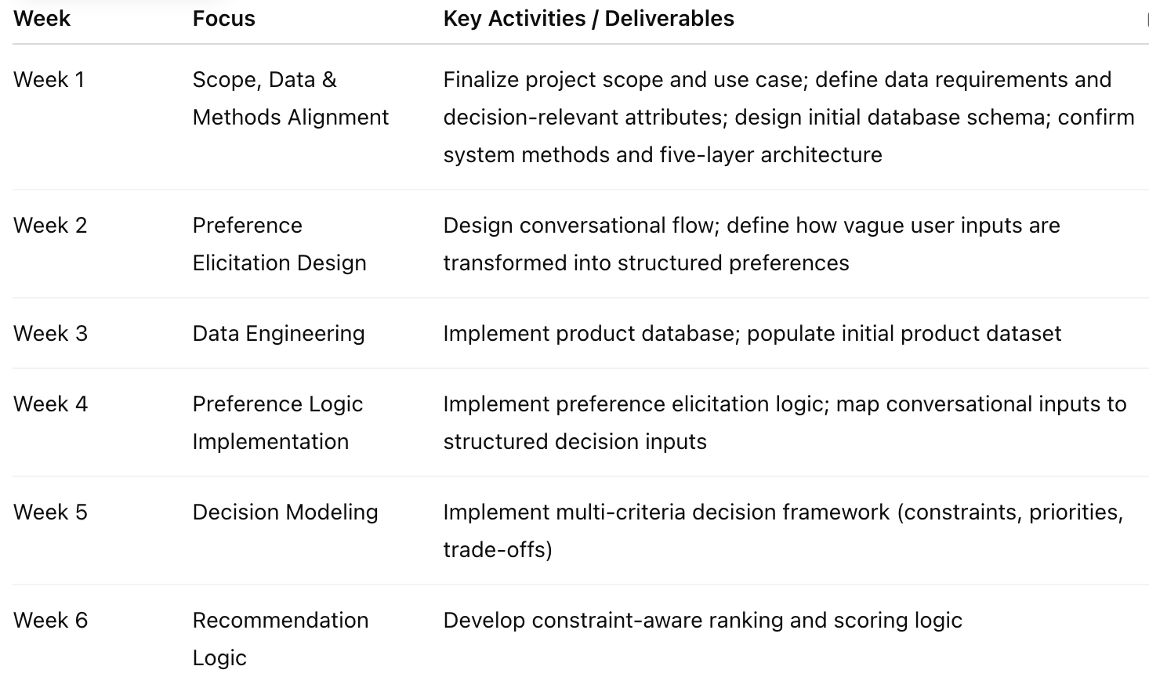
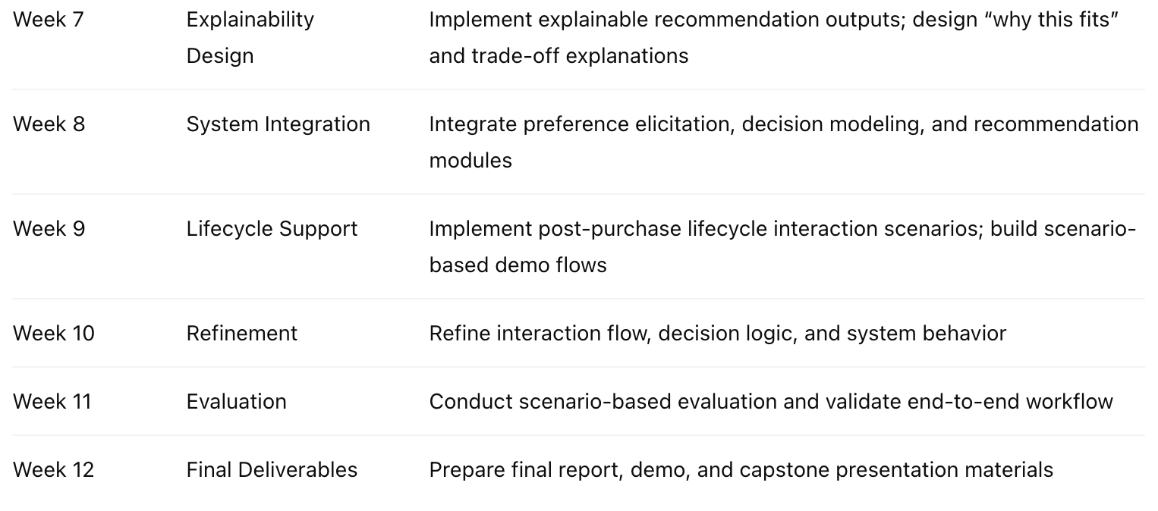

9. Budget
This project is designed to be completed with minimal cost, leveraging publicly available data sources, open-source tools, and local development environments.
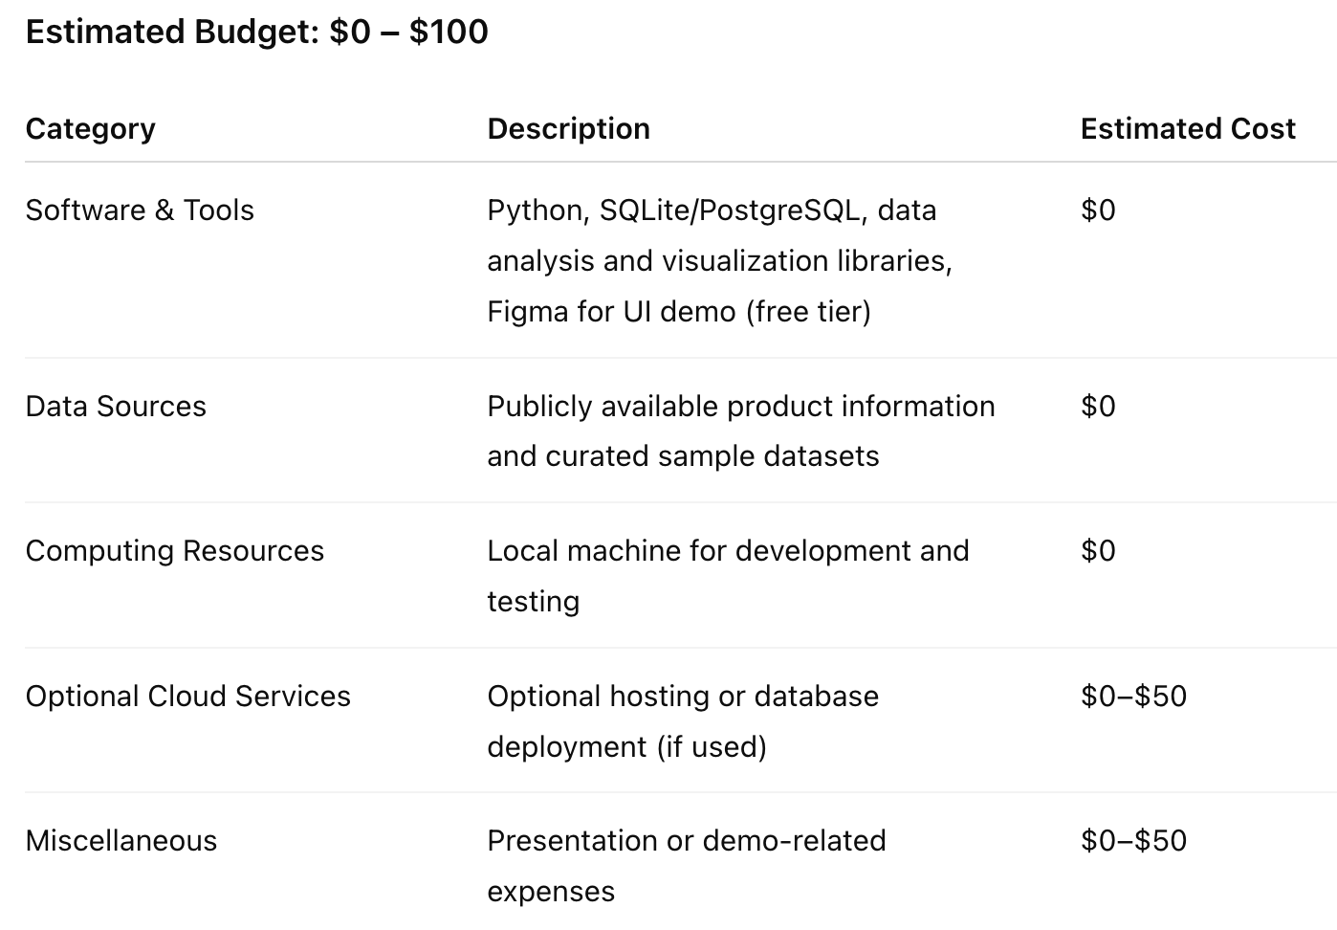

10. Demo
This project demonstrates a human-centered, explainable shopping assistant that transforms vague, everyday needs into structured decision support, and extends value beyond the point of purchase.
The proposed product is designed as a flow-based shopping assistant system.
For clarity and feasibility within the capstone scope, the system is demonstrated through a focused scenario-based demo (Kitchen Assistant).

https://www.figma.com/make/aWLzmXUOSrSZKsDhWrxPUj/Interactive-Shopping-Assistant-Demo?p=f&t=61G2YpYQkj1dIX2v-0&fullscreen=1

